ingb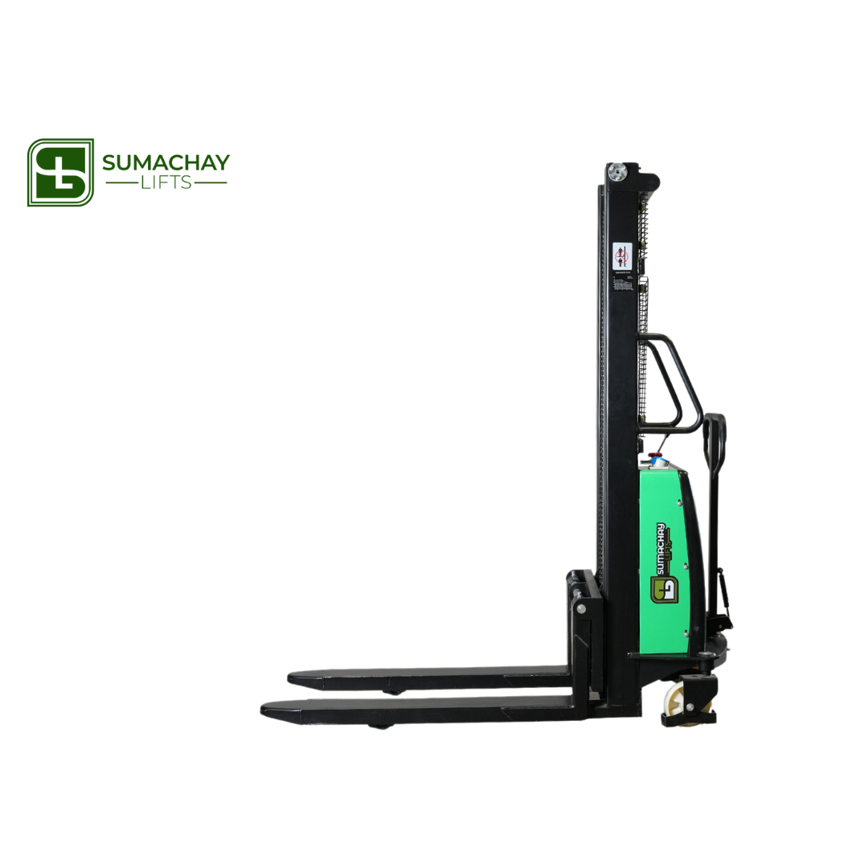

SSE20 SEMI ELECTRIC PALLET STACKER

## CAPACITY 1500 KG | STANDARD

**Efficient Lifting Power**

Experience unparalleled efficiency with the SSE20 semi electric pallet stacker, boasting a high-power and high-performance lifting pump. This advanced system ensures swift and effective lifting operations, streamlining your material handling processes with unmatched precision.

**Maneuverability Redefined**

The side-driving design of the SSE20 gives it a remarkably small steering radius, providing enhanced agility in tight spaces. Coupled with a broader view, this innovative feature facilitates seamless navigation, making it the ideal choice for precision handling in diverse working environments.

**Compact and Powerful Driving System**

Equipped with a driving system featuring a permanent magnetic motor, the SSE20 excels with its small volume, lightweight construction, and minimal energy loss. This cutting-edge technology contributes to the stacker's overall efficiency and performance, ensuring optimal functionality with every operation.

**Built to Brave Harsh Conditions**

Crafted for durability in challenging working environments, the SSE20 semi electric pallet stacker incorporates a waterproof inching switch imported from Germany. This feature meets the demands of harsh conditions such as cold, humidity, and dust, ensuring reliable performance when you need it most.

# TECHNICAL DATA

SSE20 SEMI ELECTRIC PALLET STACKER

| 1.1 |  | Manufacturer |  |  |  | | SUMACHAY LIFTS |
| --- | --- | --- | --- | --- | --- | --- | --- |
| 1.2 |  | Model designation |  |  |  |  | SSE20 |
| 1.3 |  | Power unit: Battery, diesel, gasoline, LPG |  |  |  | | Battery powered |
| 1.4 |  | Operation |  |  |  | | Pedestrian |
| 1.5 |  | Load capacity |  | Q [t] |  | | 2 |
| 1.7 |  | Load center |  | c [mm] |  | | 450 |
| 1.9 |  | Overall Length |  | l1 [mm] |  | | 1600/1800 |
| 1.1 |  | Overall width |  | b1 / b2 [mm] |  | | 760/964 |
| 2.1 |  | Service weight |  | [kg] |  | | 380 |
| 2.2 |  | Height of mast lowered |  | h1 [mm] |  | | 1577 |
| 2.3 |  | Height of mast, extended |  | h4 [mm] |  | | 2567 |
| 3.1 |  | Tyre: SE=(superelastic), P=(pneumatic) |  |  |  | | PU / Nylon |
| 3.2 |  | Tyre size, front |  | [mm] |  | | 180x50 |
| 3.3 |  | Tyre size, rear |  | [mm] |  | | 74x70 |
| 3.5 |  | Wheelbase |  | y [mm] |  | | 1190 |
| 3.6 |  | Lift Height |  | h3 [m] |  | | 2000 |
| 4.10 |  | Fork Carriage Width |  | [mm] |  | | 800 |
| 4.15 |  | Fork height, lowered |  | h13 [mm] |  | | 85 |
| 4.16 |  | Ground Clearance (below mast) |  | [mm] |  | | 27 |
| 4.20 |  | Length to fork face |  | l2 [mm] |  | | 700 |
| 4.21 |  | Overall width |  | b1 / b2 [mm] |  | | 760/964 |
| 4.22 |  | Fork dimensions |  | sxexl [mm] |  | | 60x150x900 |
| 4.25 |  | Axle Centre to fork face |  | x [mm] |  | | 700 |
| 4.32 |  | Aisle width, 1000 x 1200 along forks |  | Ast [mm] |  | | 2250 |
| 4.34 |  | Aisle width, 800 x 1200 along forks |  | Ast [mm] |  | | 2040 |
| 4.35 |  | Turning radius |  | Wa [mm] |  | | 1350 |
| 5.1 |  | Width of forks |  | b5 [mm] |  | | 550/640 |
| 5.2 |  | Lifting speed, with/without load |  | [mm/s] |  | | 45/110 |
| 5.3 |  | Lowering speed, with/without load |  | [mm/s] |  | | 110/80 |
| 5.8 |  | Track width |  | b10 [mm] |  | | 648 |
| 5.9 |  | Track width |  | b11 [mm] |  | | 390/490 |
| 5.10 |  | Service brake |  |  |  | | Machinery |
| 6.1 |  | Lift |  | h3 [mm] |  | | 2000 |
| 6.2 |  | Lift motor rating at S3 15 % |  | [kW] |  | | 1.6 |
| 6.3 |  | Battery |  |  |  | | Li-ion |
| 6.4 |  | Battery voltage / rated capacity |  | [ V/ Ah] |  | | 12 / 120 |
| 6.5 |  | Battery weight |  | kg |  | | 36 |
| 6.6 |  | Energy consumption acc. to VDI cycle |  | [kW/h] |  | | n / a |
| 8.1 |  | Type of drive control |  |  |  | | DC |
| 8.4 |  | Noise level |  | [dB (A)] |  | | < 70 |

