ingb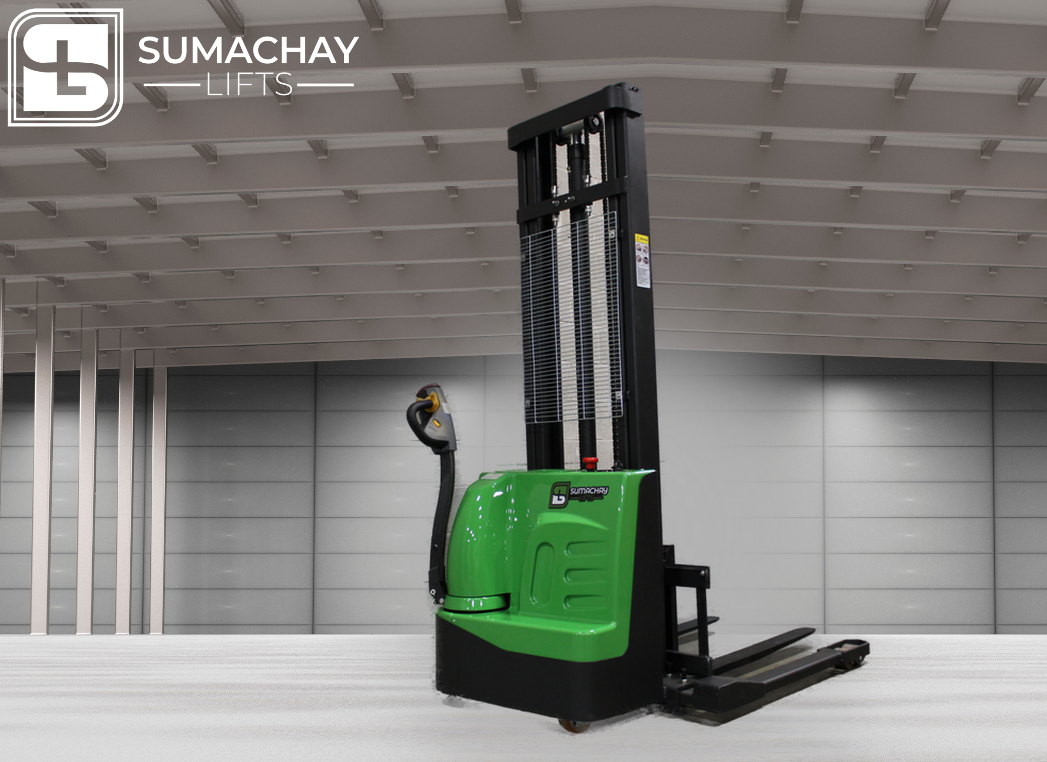

SST15 ELECTRIC PALLET STACKER

## CAPACITY 1500 KG | STANDARD

**Efficient Lifting Power**

Experience unparalleled efficiency with the SST15 electric pallet stacker, boasting a high-power and high-performance lifting pump. This advanced system ensures swift and effective lifting operations, streamlining your material handling processes with unmatched precision.

**Maneuverability Redefined**

The side-driving design of the SST15 gives it a remarkably small steering radius, providing enhanced agility in tight spaces. Coupled with a broader view, this innovative feature facilitates seamless navigation, making it the ideal choice for precision handling in diverse working environments.

**Compact and Powerful Driving System**

Equipped with a driving system featuring a permanent magnetic motor, the SST15 excels with its small volume, lightweight construction, and minimal energy loss. This cutting-edge technology contributes to the stacker's overall efficiency and performance, ensuring optimal functionality with every operation.

**Built to Brave Harsh Conditions**

Crafted for durability in challenging working environments, the SST15 electric pallet stacker incorporates a waterproof inching switch imported from Germany. This feature meets the demands of harsh conditions such as cold, humidity, and dust, ensuring reliable performance when you need it most.

# TECHNICAL DATA

SST15 ELECTRIC PALLET STACKER

| 1.1 |  | Manufacturer |  |  |  | | SUMACHAY LIFTS |
| --- | --- | --- | --- | --- | --- | --- | --- |
| 1.2 |  | Model designation |  |  |  |  | SST15 |
| 1.3 |  | Power unit: Battery, diesel, gasoline, LPG |  |  |  | | Battery powered |
| 1.4 |  | Operation |  |  |  | | Pedestrian |
| 1.5 |  | Load capacity |  | Q [t] |  | | 1.5 |
| 1.7 |  | Load center |  | c [mm] |  | | 600 |
| 1.9 |  | Overall Length |  | l1 [mm] |  | | 1740 |
| 1.1 |  | Overall width |  | b1 / b2 [mm] |  | | 795 |
| 2.1 |  | Service weight |  | [kg] |  | | 149 |
| 2.2 |  | Axle load with load, front/rear |  | [kg] |  | | 420 / 910 |
| 2.3 |  | Axle load without load, front/rear |  | [kg] |  | | 110 / 20 |
| 3.1 |  | Tyre: SE=(superelastic), P=(pneumatic) |  |  |  | | PU / PU |
| 3.2 |  | Tyre size, front |  | [mm] |  | | 210x70 |
| 3.3 |  | Tyre size, rear |  | [mm] |  | | 80x60 |
| 3.5 |  | Wheels, number front/rear (X=drive) |  |  |  | | 1x+/4 |
| 3.6 |  | Lift Height |  | h3 [m] |  | | 3500 |
| 4.10 |  | Fork Carriage Width |  | [mm] |  | | 800 |
| 4.15 |  | Fork height, lowered |  | h13 [mm] |  | | 86 |
| 4.16 |  | Ground Clearance (below mast) |  | [mm] |  | | 40 |
| 4.20 |  | Length to fork face |  | l2 [mm] |  | | 500 |
| 4.21 |  | Overall width |  | b1 / b2 [mm] |  | | 685 |
| 4.22 |  | Fork dimensions sxexl |  | sxexl [mm] |  | | 50x150x1150 |
| 4.25 |  | Distance between fork arms |  | b5 [mm] |  | | 570 - 695 |
| 4.32 |  | Aisle width, 1000 x 1200 along forks |  | Ast [mm] |  | | 2075 |
| 4.34 |  | Aisle width, 800 x 1200 along forks |  | Ast [mm] |  | | 2040 |
| 4.35 |  | Turning radius |  | Wa [mm] |  | | 1342 |
| 5.1 |  | Travelling speed, with/without load |  | [km / h] |  | | 4.0 / 4.1 |
| 5.2 |  | Lifting speed, with/without load |  | [m/s] |  | | 0.02 / 0.025 |
| 5.3 |  | Lowering speed, with/without load |  | [m/s] |  | | 0.06 / 0.03 |
| 5.8 |  | Max. gradability, laden/ unladen |  | % |  | | 5 /10 |
| 5.9 |  | Acceleration time with/without load |  | [s] |  | | 1 / 2 |
| 5.10 |  | Service brake |  |  |  | | Electric |
| 6.1 |  | Drive motor rating S2 60 min |  | [kW] |  | | 0.75 |
| 6.2 |  | Lift motor rating at S3 10 % |  | [kW] |  | | 2.2 |
| 6.3 |  | Battery acc. to DIN 43531/ 35/ 36 A, B, C, no |  |  |  | | Li-ion |
| 6.4 |  | Battery voltage, nominal capacity K5 |  | [ V/ Ah] |  | | 24 / 200 |
| 6.5 |  | Battery weight |  | kg |  | | 54 |
| 6.6 |  | Energy consumption acc. to VDI cycle |  | [kW/h] |  | | n / a |
| 8.1 |  | Type of drive control |  |  |  | | DC |
| 8.4 |  | Noise level |  | [dB (A)] |  | | < 70 |

